
YENEPOYA INSTITUTE OF ARTS SCIENCE COMMERCE AND MANAGEMENT
Najiya Sulthana
High Level Design (HLD)
Personalized Healthcare Recommendation System
Course: BSC Artificial Intelligence ML Data science
Register No:23BSAMD023
Industry Mentor: Sumit Kumar Shukla
Guided By: Ankitha Poojary ma’am

Table of content
1. Introduction……………………………………………………………………………………………………………3
1.1 Scope of the document………………………………………………………………………………………… 3
1.2 Intended Audience………………………………………………………………………………………………3
1.3 System overview………………………………………………………………………………………………… 3
2. System Design…………………………………………………………………………………………………………… 4
2.1 Application Design………………………………………………………………………………………………. 4
2.2 Process Flow…………………………………………………………………………………………………… …4
2.3 Information Flow………………………………………………………………………………………………….5
2.4 Components Design……………………………………………………………………………………………….5
2.5 Key Design Considerations……………………………………………………………………………………….5
2.6 API Catalogue………………………………………………………………………………………………...........6
3. Data Design………………………………………………………………………………………………………………..7
3.1 Data Model………………………………………………………………………………………………………….8
3.2 Data Access Mechanism……………………………………………………………………………………………8
3.3 Data Retention Policies…………………………………………………………………………………………….8
3.4 Data Migration………………………………………………………………………………………………….….9
4. Interfaces…………………………………………………………………………………………………………………..9
5. State and Session Management………………………………………………………………………………………….10
6. Caching…………………………………………………………………………………………………………………….11
7. Non-Functional Requirements……………………………………………………………………………………………11
7.1 Security Aspects………………………………………………………………………………………………............11
7.2 Performance Aspects………………………………………………………………………………………………...11
8. References…………………………………………………………………………………………………………….........12

1.Introduction
Healthcare data is growing rapidly, making it difficult for users to manually identify relevant health-related information. Users often struggle to find appropriate healthcare suggestions based on symptoms, diseases, or treatments.
The Healthcare Recommendation System is developed to solve this problem by automatically suggesting similar healthcare items using data-driven techniques. The system uses Python libraries such as Pandas and Scikit-learn to process data and generate recommendations. A Streamlit-based interface is used to provide an interactive and user-friendly experience.
This system helps users quickly identify related healthcare information, improving accessibility and decision-making.

  - Scope of the Document
This document provides a high-level overview of the system design, architecture, and working principles of the Healthcare Recommendation System. It explains how data flows through the system and how recommendations are generated.

  - Intended Audience
• Academic evaluators
• Developers and designers
• Project supervisors
• Students and researchers

  - System Overview
The system allows users to enter a healthcare item or symptom and receive similar recommendations. It uses TF-IDF and cosine similarity to analyze textual data and find relationships between items.
The system is designed to be simple, efficient, and scalable for small to medium datasets.

2. System Design
2.1 Application Design

The Healthcare Recommendation System is designed as a modular application where different components work together to process user input and generate meaningful recommendations. The system follows a structured workflow in which each module performs a specific function, ensuring efficiency and maintainability.
The application begins with the Input Module, where the user enters a healthcare item such as a disease, treatment, or health plan through the Streamlit interface. This input is then passed to the Data Processing Module, which is responsible for loading the dataset using Pandas, cleaning the data, removing duplicates, and preparing it for further analysis.
After preprocessing, the data is handled by the Feature Engineering Module, where textual information such as tags is converted into numerical format using the TF-IDF (Term Frequency–Inverse Document Frequency) technique. This step is crucial as it transforms unstructured text data into a machine-readable form.
The processed data is then passed to the Similarity Module, which calculates the similarity between healthcare items using cosine similarity. This module generates similarity scores that represent how closely related different items are.
Based on these similarity scores, the Recommendation Module identifies the most relevant healthcare items related to the user’s input. It sorts the items, removes duplicates, and selects the top recommendations.
Finally, the Output Module displays the results to the user in a clear and organized manner through the Streamlit interface. Additionally, the Visualization Component presents graphs such as histograms and line charts to provide a better understanding of the recommendations.
Overall, the application design ensures a smooth flow of data between modules, enabling the system to deliver accurate and efficient healthcare recommendations.

2.2 Process Flow
The process flow of the Healthcare Recommendation System describes the sequence of operations performed from the moment a user enters input to the generation of final recommendations. It ensures that data is processed systematically to produce accurate and meaningful results.
The process begins when the user enters a healthcare item, such as a disease or treatment, into the search bar provided in the Streamlit interface. The system first validates the input to ensure that it exists in the dataset. If the input is invalid, an appropriate message is displayed to guide the user.
Once the input is validated, the system loads the dataset from the CSV file using Pandas. The dataset contains healthcare items along with their associated tags. The data is then preprocessed by converting text into lowercase, removing duplicates, and cleaning unnecessary characters to maintain consistency.
After preprocessing, the system applies TF-IDF (Term Frequency–Inverse Document Frequency) to convert textual data into numerical vectors. This transformation allows the system to analyze text data mathematically.

Next, cosine similarity is used to compute similarity scores between the selected healthcare item and all other items in the dataset. These scores indicate how closely related different items are based on their textual features.

The system then sorts the similarity scores in descending order and selects the top matching items. Duplicate entries are filtered out to ensure that only unique recommendations are displayed.
Finally, the recommended healthcare items are presented to the user through the interface. In addition to the results, the system may display graphical visualizations such as histograms or line charts to provide better insights into the recommendations.
This structured process flow ensures that the system operates efficiently, transforming raw input into useful healthcare recommendations in a clear and systematic manner.

2.3 Information Flow
The Information Flow describes how data moves through different components of the Healthcare Recommendation System from input to output.
The system follows a structured flow where user input is processed, analyzed, and converted into meaningful recommendations.

Flow Description
- User Input Stage
The process begins when the user enters a healthcare item (such as a disease, treatment, or health plan) into the search bar provided in the Streamlit interface.

- Input Validation
The system checks whether the entered item exists in the dataset. If the input is invalid or not found, an appropriate message is displayed to the user.

- Data Retrieval
Once the input is validated, the system retrieves the dataset from the CSV file using Pandas. The relevant columns such as item_name and tags are accessed.

- Data Preprocessing
The dataset undergoes preprocessing steps including:
  - Conversion of text to lowercase
  - Removal of duplicates
  - Cleaning of unnecessary characters
- Feature TransformationThe cleaned textual data is transformed into numerical vectors using the TF-IDF (Term Frequency–Inverse Document Frequency) technique. This helps in representing text data in a machine-readable format.

- Similarity Computation
The system computes similarity between items using cosine similarity. A similarity matrix is generated internally to measure how closely related different healthcare items are.

- Recommendation Generation
Based on similarity scores, the system identifies the most relevant items related to the user’s input. Duplicate results are filtered, and the top recommendations are selected.

- Output Presentation
The final recommendations are displayed on the user interface. Additionally, graphs such as histograms or line charts are shown to provide visual insights into the recommendations.

2.4 Components Design
The Healthcare Recommendation System is composed of multiple components, each responsible for a specific functionality. These components work together to process user input, analyze data, and generate recommendations efficiently.

1. Input Component
This component handles user interaction and input collection.
Functions:
- Accepts healthcare item through search bar
- Sends input to processing module
- Ensures smooth user interaction

2. Data Processing Component
This component prepares the dataset for analysis.
Functions:
- Loads dataset from CSV file using Pandas
- Cleans data by converting text to lowercase
- Removes duplicate entries
- Handles missing values
This step ensures the data is consistent and ready for further processing.

3. Feature Engineering Component
This component converts textual data into numerical form.
Functions:
- Applies TF-IDF (Term Frequency–Inverse Document Frequency)
- Converts tags into vectors
- Assigns importance to words

This transformation enables the system to process text mathematically.

4. Similarity Computation Component
This component calculates similarity between healthcare items.
Functions:
- Uses cosine similarity
- Generates similarity matrix
- Measures closeness between items
This is the core logic of the recommendation system.

5. Recommendation Engine
This component generates the final recommendations.
Functions:
- Identifies similar healthcare items
- Sorts similarity scores
- Filters duplicate results
- Selects top N recommendations

6. Visualization Component
This component provides graphical insights.
Functions:
- Displays histogram
- Displays line chart
- Helps users understand recommendation trends

7. Output Component
This component displays final results to the user.
Functions:
- Shows recommended items
- Displays clean UI output
- Presents graphs and insights

Component Interaction
All components are interconnected and work in sequence:
Input → Data Processing → Feature Engineering → Similarity Computation → Recommendation Engine → Output

2.5 Key Design Considerations
The design of the Healthcare Recommendation System is guided by several important factors to ensure that the system is efficient, reliable, and user-friendly. These considerations help in building a system that not only functions correctly but also provides a good user experience.

One of the primary considerations is accuracy. The system must generate relevant and meaningful recommendations based on user input. This is achieved by using effective techniques such as TF-IDF and cosine similarity to analyze textual data and identify relationships between healthcare items.

Another important factor is performance. The system should respond quickly to user queries without delays. Efficient data processing using libraries like Pandas and optimized similarity computation ensures fast execution, especially for small to medium-sized datasets.
Usability is also a key consideration. The system is designed with a simple and intuitive interface using Streamlit, allowing users to easily enter input and view results without any technical knowledge.
The system also focuses on scalability. Although currently designed for smaller datasets, the architecture allows future expansion to handle larger datasets or integration with databases without major changes.
Maintainability is ensured through a modular design. Each component, such as data processing, similarity computation, and recommendation generation, is independent, making it easier to update or modify the system.
Another important aspect is data quality. Proper preprocessing, including cleaning and removing duplicates, ensures that the recommendations are based on accurate and consistent data.
Finally, reliability is considered by handling errors such as invalid input or missing data. The system provides appropriate messages and fallback options to ensure smooth operation.
Overall, these design considerations ensure that the Healthcare Recommendation System is efficient, scalable, user-friendly, and capable of delivering accurate recommendations.

2.6 API Catalogue
The Healthcare Recommendation System does not use any external APIs. All operations are performed using internal Python libraries such as Pandas for data processing, Scikit-learn for TF-IDF and cosine similarity, and Streamlit for the user interface. The system works with a local CSV dataset, ensuring fast and secure execution.

3. Data Design
3.1 Data Model
The Healthcare Recommendation System uses a structured dataset stored in CSV format, which is loaded into a Pandas DataFrame for processing and analysis. The dataset contains information

about healthcare items and their associated tags, which are used to generate recommendations. The item_name field represents the name of the healthcare item, while the tags field contains keywords describing the item. During processing, the textual data is converted into numerical form using TF-IDF, and similarity scores are computed internally using cosine similarity. This data model ensures efficient storage, processing, and retrieval of information for generating accurate recommendations.

The key data fields used in the system are summarized below:

Field | Description
item_name | Name of the healthcare item (e.g., disease, treatment)
tags | Keywords describing the healthcare item
similarity_score | Similarity value calculated internally

3.2 Data Access Mechanism
The dataset is stored in CSV format and accessed using the Pandas library. The data is loaded into a DataFrame, which allows efficient data manipulation and processing. Required fields such as item_name and tags are retrieved and used for generating recommendations.
Additionally, the DataFrame structure enables quick filtering and searching operations. The system also ensures that data is accessed in a read-only manner to prevent accidental modification of the original dataset.

3.3 Data Retention Policies
The system does not store any user data permanently. All data processing is done temporarily during execution. This ensures data privacy and security, as no sensitive information is saved or reused after the session ends.

The dataset used is static and remains unchanged during execution. Any temporary data generated during processing is cleared once the session is completed.

3.4 Data Migration
The system currently uses a static CSV dataset and does not require data migration. However, in future, the system can be extended to use databases or external data sources if needed..

- Interfaces
The Healthcare Recommendation System provides a simple and user-friendly interface built using Streamlit, enabling smooth interaction between the user and the system. Users can enter a healthcare item, such as a disease or treatment, through a search bar. The system validates the input and processes it using the backend recommendation engine. The output is displayed in a clear and organized format, showing a list of recommended healthcare items related to the user’s query. In addition to textual results, the system also presents graphical visualizations such as histograms or line charts to provide better insights into the recommendations. The interface is designed to be intuitive and responsive, ensuring that users can easily navigate the application, enter queries, and understand the results without requiring any technical knowledge. This enhances the overall user experience and usability of the system.
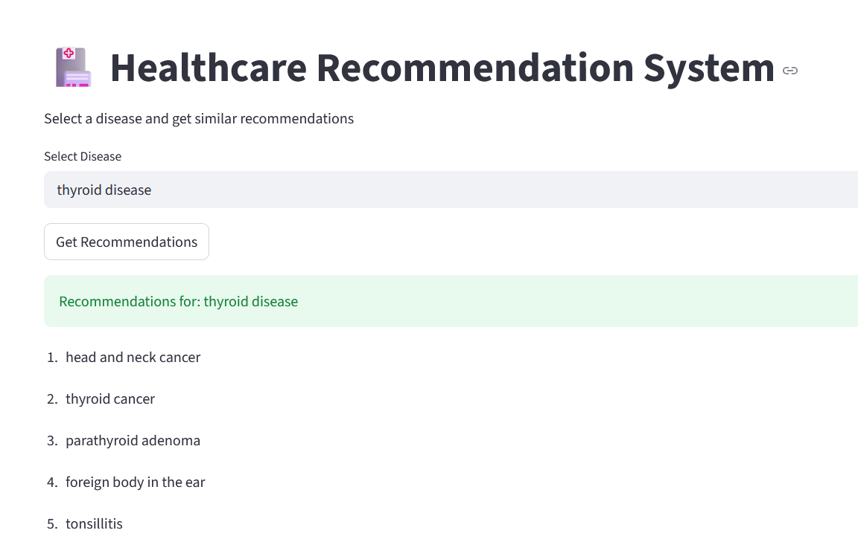

- State and Session Management
The Healthcare Recommendation System uses Streamlit, which automatically manages user sessions during application runtime. Each user interaction, such as selecting a healthcare item or clicking the recommendation button, is handled within a session. The system temporarily stores user input and generated results during execution, ensuring smooth interaction without reloading the entire application.
The session state helps maintain consistency in user experience by preserving input values and results while the application is running. It also allows the system to handle multiple interactions efficiently without losing previously computed results. Additionally, session management ensures that each user request is processed independently without interference from other sessions.
Furthermore, the system ensures that session data is lightweight and only essential information is stored temporarily. No session data is stored permanently, and all data is cleared once the application is refreshed or closed. This approach maintains simplicity, efficiency, and data privacy.

- Caching
Caching is used to improve the performance of the Healthcare Recommendation System by reducing redundant computations. Frequently used data, such as the dataset and processed results, can be stored temporarily to avoid reloading and recomputing them multiple times.
Streamlit provides built-in caching mechanisms, such as st.cache_data(), which can be used to cache data loading and preprocessing steps. This significantly reduces execution time and improves system responsiveness, especially when working with larger datasets.
Additionally, caching helps in minimizing resource usage by avoiding repeated calculations of similarity scores. It also ensures faster response times for repeated user queries. The caching mechanism is designed to update automatically when there are changes in the dataset or logic, ensuring that the system always provides accurate and up-to-date results.

- Non-Functional Requirements

The Healthcare Recommendation System is designed to meet several non-functional requirements to ensure efficiency, reliability, and usability.

7.1 Security Aspects
The system ensures basic security by not storing any sensitive user data. All operations are performed locally, and user inputs are processed temporarily during runtime. This reduces the risk of data leakage. Additionally, input validation is performed to handle invalid or unexpected user entries, ensuring safe system behavior. Since the system does not rely on external APIs or databases, it minimizes exposure to external security threats.

7.2 Performance Aspects
The system is designed to provide fast and efficient recommendations. Data processing is optimized using libraries like Pandas and Scikit-learn, which handle computations efficiently. The use of caching reduces redundant processing and improves response time. The system performs well for small to medium-sized datasets and provides quick results to users without noticeable delay.

8. References
1.Scikit-learn. Machine Learning in Python Documentation.
2.Pandas. Python Data Analysis Library Documentation.
3.Streamlit. Streamlit Documentation for Web App Development.
4.Python Software Foundation. Python Documentation.
5.Géron, A. Hands-On Machine Learning with Scikit-Learn.
6.Ricci, F., Rokach, L., & Shapira, B. Recommender Systems Handbook.
7.Salton, G., & McGill, M. Introduction to Modern Information Retrieval.
8.Research papers and articles on Content-Based Recommendation Systems.

9.Online tutorials and educational resources related to TF-IDF and Cosine Similarity.

